1️⃣ Introduction to Feed Forward Neural Network (FFNN)
🔹 What is a Feed Forward Network?
A Feed Forward Neural Network is the simplest type of Artificial Neural Network where:
👉 Information moves in one direction only
👉 From Input → Hidden → Output
👉 No loops, no feedback connections
Data never travels backward during prediction.

🔹 Structure
Input Layer → Hidden Layer(s) → Output Layer
Each neuron:
$$Z=W⋅X+b \\ A=Activation(Z)$$

🔹 Why called "Feed Forward"?
Because:
- Data is fed forward.
- No cycles like in RNN.
- No memory of previous inputs.

🔹 Where it is used?
- Classification
- Regression
- Basic pattern recognition

2️⃣ Perceptron (Single Layer Neural Network)
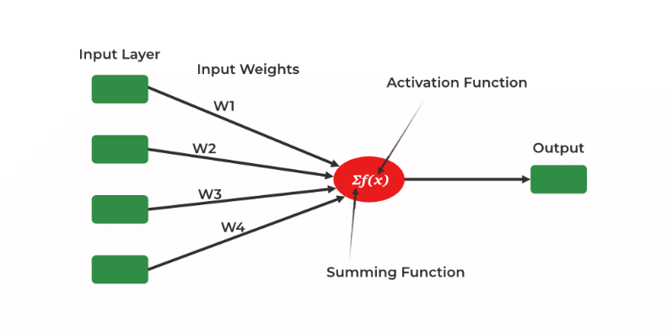
The Perceptron is the first neural network model introduced by:
👉 Frank Rosenblatt in 1958.
It is the simplest type of Feed Forward Network.

🔹 Structure of Perceptron
It has:
- Input layer
- Single output neuron
- No hidden layer
Mathematical Representation
$$Z=W_{1}X_{1}+W_{2}X_{2}+...+b$$
Then apply activation:
$$Y=f(Z)$$

🔹 Activation Function Used
Perceptron uses Step Function (Heaviside Function):
$$f(Z)=\left\{\begin{matrix}1 & \text{if }Z≥0 \\ 0 & \text{if }Z<0\end{matrix}\right.$$
Output is binary:
0 or 1

🔹 What can Perceptron do?
It performs:
✔ Binary classification
✔ Linearly separable problems
Example:
- Spam vs Not Spam
- Pass vs Fail
- Yes vs No

🔹 Geometric Interpretation
Perceptron creates a:
👉 Linear decision boundary
In 2D → a straight line
In 3D → a plane
In higher dimensions → a hyperplane
Equation of decision boundary:
$$W⋅X+b=0$$

3️⃣ Learning in Perceptron
Perceptron updates weights using:
Perceptron Learning Rule
If prediction is wrong:
$$W=W+η(y_{true}-y_{pred})X \\ b=b+η(y_{true}-y_{pred})$$
Where:
- η = learning rate
- y = true label
- y_pred = predicted label
Weights update only when error occurs.

4️⃣ Limitations of Perceptron
This is VERY important.

❌ 1. Cannot Solve Non-Linear Problems
Perceptron only works for linearly separable data.
Classic Example: XOR Problem
XOR truth table:
X1 | X2 | Output
0 | 0 | 0
0 | 1 | 1
1 | 0 | 1
1 | 1 | 0
This is NOT linearly separable.
No straight line can separate these points.

❌ 2. Only Binary Classification
Perceptron outputs only 0 or 1.
Cannot directly handle:
- Multi-class problems
- Regression problems

❌ 3. Uses Hard Threshold (Step Function)
Step function:
- Not differentiable
- Cannot use gradient descent
- Learning is unstable

❌ 4. No Hidden Layers
Perceptron cannot learn:
- Complex patterns
- Feature interactions
- Hierarchical representations

🔥 Historical Impact
In 1969, Marvin Minsky and Seymour Papert proved perceptron cannot solve XOR.
This caused the first AI winter.

5️⃣ Multi-Layer Perceptron (MLP)
To overcome perceptron limitations, we use:
👉 Multi-Layer Perceptron (MLP)

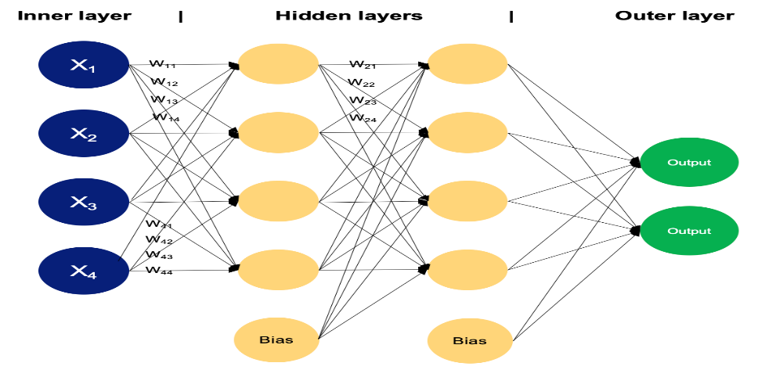

🔹 What is MLP?
An MLP is:
✔ A Feed Forward Neural Network
✔ With one or more hidden layers
✔ Uses non-linear activation functions
✔ Trained using Backpropagation

🔹 Structure
Input Layer → Hidden Layer(s) → Output Layer
Unlike Perceptron:
- Has multiple neurons per layer
- Can have multiple hidden layers

🔹 Activation Functions Used in MLP
Instead of step function, MLP uses:
- ReLU
- Sigmoid
- Tanh
- Softmax (output layer)
These are differentiable.

🔹 Why MLP is Powerful?
Hidden layers allow:
- Learning complex patterns
- Non-linear decision boundaries
- Feature combinations

🔹 How MLP Solves XOR?
Hidden layer transforms input space.
Example:
Layer 1 learns:
- X1 AND NOT X2
- NOT X1 AND X2
Layer 2 combines them.
Thus, non-linear problem becomes solvable.

6️⃣ Key Differences: Perceptron vs MLP
Feature | Perceptron | MLP
Hidden Layers | No | Yes
Activation | Step | ReLU/Sigmoid/Tanh
Problems solved | Linear only | Linear + Non-linear
Learning method | Perceptron rule | Backpropagation
Multi-class | No | Yes
Regression | No | Yes

🎯 Intuitive Understanding
Perceptron
Single straight-line decision maker.
Simple but limited.

MLP
Stack of perceptrons.
Learns:
Edges → Shapes → Patterns → Concepts
Just like deep learning hierarchy.

🧠 Big Picture
Perceptron = Foundation
MLP = Real practical neural network
Modern deep learning = Large MLPs + CNN + Transformers

Working of Multi-Layer Perceptron
Let's see working of the multi-layer perceptron. The key mechanisms such as forward propagation, loss function, backpropagation and optimization.
1. Forward Propagation
In forward propagation the data flows from the input layer to the output layer, passing through any hidden layers. Each neuron in the hidden layers processes the input as follows:
1. Weighted Sum: The neuron computes the weighted sum of the inputs:
$$z=\sum_{i}{w_{i}}x_{i}+b$$
Where:
- $x_{i}$​ is the input feature.
- $w_{i}$​ is the corresponding weight.
- $b$ is the bias term.

2. Activation Function: The weighted sum z is passed through an activation function to introduce non-linearity. Common activation functions include:
- Sigmoid: $σ(z)=\frac{1}{1+e^{-z}}$
- ReLU (Rectified Linear Unit): $f(z)=max⁡(0,z)$
- Tanh (Hyperbolic Tangent): $tanh⁡(z)=\frac{2}{1+e^{-2z}}-1$
2. Loss Function
Once the network generates an output the next step is to calculate the loss using a loss function. In supervised learning this compares the predicted output to the actual label.
For a classification problem the commonly used binary cross-entropy loss function is:
$$L=-\frac{1}{N}\sum_{i=1}^{N}{\left[y_{i}log⁡({\hat{y}}_{i})+(1-y_{i})log⁡(1-{\hat{y}}_{i})\right]}$$
Where:
- $y_{i}$ is the actual label.
- ${\hat{y}}_{i}$ is the predicted label.
- $N$ is the number of samples.
For regression problems the mean squared error (MSE) is often used:
$$MSE=\frac{1}{N}\sum_{i=1}^{N}{(}y_{i}-{\hat{y}}_{i})^{2}$$
3. Backpropagation
The goal of training an MLP is to minimize the loss function by adjusting the network's weights and biases. This is achieved through backpropagation:
- Gradient Calculation: The gradients of the loss function with respect to each weight and bias are calculated using the chain rule of calculus.
- Error Propagation: The error is propagated back through the network, layer by layer.
- Gradient Descent: The network updates the weights and biases by moving in the opposite direction of the gradient to reduce the loss: $w=w-η⋅\frac{∂L}{∂w}$
Where:
- $w$ is the weight.
- $η$ is the learning rate.
- $\frac{∂L}{∂w}$ is the gradient of the loss function with respect to the weight.
4. Optimization
MLPs rely on optimization algorithms to iteratively refine the weights and biases during training. Popular optimization methods include:
- Stochastic Gradient Descent (SGD): Updates the weights based on a single sample or a small batch of data: $w=w-η⋅\frac{∂L}{∂w}$
- Adam Optimizer: An extension of SGD that incorporates momentum and adaptive learning rates for more efficient training:
- $m_{t}=β_{1}m_{t-1}+(1-β_{1})⋅g_{t}$
- $v_{t}=β_{2}v_{t-1}+(1-β_{2})⋅g_{t}^{2}$
Here $g_{t}$​ represents the gradient at time $t$ and $β_{1},β_{2}$ are decay rates.

